|  |  |  |
| --- | --- | --- |
| SRR | February 16  2016 | |
| Making Facility Management more intelligent and efficient. | | Systems Requirements Review |

|  |  |  |  |
| --- | --- | --- | --- |
| **Revision record** | | | |
| Version | Date | Attendees | Comment |
| 1.0.0 | 16.02.16 | Arshad Shakil,  Badis Madani,  [Håkon Hedlund](https://www.facebook.com/hakon.hedlund)**,**  Zhili Shao |  |

Contents

1. Identification of opportunity 3

2. SMART Goal Definition 3

3. WBS 3

4. NTCP (Project taxonomy) 5

5. Concepts of Operations (CONOPS) 6

a) Statement of the goals and Objectives of System 6

b) Boundaries of the system 6

c) Stakeholder and interactions between them 6

d) Policies and/or constraints that affect the system or that influence it. 7

e) Conceptual view of the system. 7

f) Processes involved in fielding, commissioning, using, maintaining and retiring the system. 8

6. Project Plan 8

a) Gantt Chart 8

b) PERT/CPM 8

7. Project Team 8

a) Belbin test result 8

b) Organization Structure 9

8. Risk Management Plan 10

# Identification of opportunity

The traditional HVAC system needs an improvement to optimize users’ experience and make maintainers’ work efficient.

For the HVAC users, a comfortable customized indoor environment is needed. The HVAC control system should be intelligent enough to make the setting process easy. There should be more methods for system configuration except fixed control panel. Using browser, apps to realize remote control has become a trend. Also for the configuration strategies, more factors such as time, weather should be added. In order to make the system work atomically, some algorithms can be designed to adjust the indoor environment.

For the HVAC maintainers, they always have responsibility to concern about the electricity cost of HVAC system. When some problem happens to the HVAC system, they often spend much more time on troubleshooting rather than fixing the problem. So a troubleshooting mechanism will help them a lot. Now FM companies often maintain lots of buildings at one time, if most of their maintenance and monitor about building can be down online through a remote control, their work and cost will be reduced a lot.

These problems about HVAC control system has existed for a long time. Now new technology gives us more possibility to solve them.

# SMART Goal Definition

The goal of our project is to design a smart control system for HVAC services in facilities, to make it more efficient and easier to use, by 1st May 2016.

# WBS

A [work breakdown structure](http://www.matchware.com/en/products/mindview/mindview2_be/wbs.htm?utm_campaign=wbs&utm_source=en-home-to-wbs-page&utm_medium=link) is a key project deliverable that organizes the team's work into manageable sections. The Project Management Body of Knowledge ([PMBOK](http://www.workbreakdownstructure.com/work-breakdown-structure-according-to-pmbok.php)) defines the work breakdown structure as a "deliverable oriented hierarchical decomposition of the work to be executed by the project team." The work breakdown structure visually defines the scope into manageable chunks that a project team can understand, as each level of the work breakdown structure provides further definition and detail. Figure (below) depicts a sample work breakdown structure for our project.

Facilities management project

Research

Research the state of the art of FM

Identification of system requirements

CONOPS

Choose system design concepts

Research and identification of design concepts

Make system design

System requirements and verification methods

Describe building functions

Select design concept

Identify service opportunities

Functional analysis

System architecture

Verification of system requirements

Figure: Work Breakdown Structure.

# NTCP (Project taxonomy)

The realization that different projects need different types of project management in order to succeed has started to sink in. During the last decade, Shenhar and Dvir’s (2007) novelty, technology, complexity, and pace (NTCP) “diamond” framework emerged as one of the most eloquent theories for project classification. Its categorization of projects is established on initial characteristics of project, based on the four independent dimensions comprised in the NTCP acronym.

The four diamond dimensions are defined as follows:

* **Novelty** – How new the product is to the customers and to the market.
* **Technology** – The extent of use of new or even non-existing technology at the time of project initiation.
* **Complexity** – Where the project’s product is located on the scale from a simple component to an array.
* **Pace** – How urgent the project is at the time of initiation; the criticality of the project’s completion time.

The NTCP framework does not specify clear-cut criteria or algorithms that might assist in performing this classification. It seems that the correct classification of a project is highly dependent on the evaluator’s experience and intuition. For our project, our team classified the project as shown in the following figure:

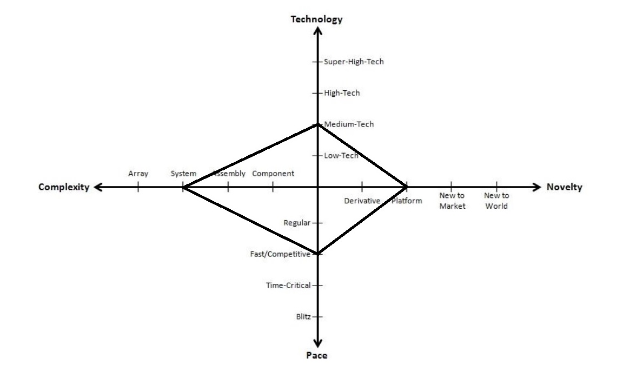

# Concepts of Operations (CONOPS)

## Statement of the goals and Objectives of System

The Goal of the smart HVAC control system is to make user change their indoor environment easily and help maintainers manage the HVAC system efficiently.

System has to give users more easy ways to configure their environment, and also it should be smart enough to keep a comfortable environment for users according to some factors like weathers, time and so on. Also it should provide some useful references when some wrong happen with HVAC system. The facility managers can also monitor the multiple HVAC systems from one location. The system would be connected to the cloud to ensure that this is possible.

.

## Boundaries of the system

The physical boundaries of the system would be the onsite heating system in the facility. This system is in turn also connected via an interface to the cloud, where data is processed and can be viewed.

Other interfaces that are external would be data pulled from the internet. This data could be weather data.

## Stakeholder and interactions between them

The internal stakeholders are:

* Visitors
* Employees
* Tenants
* Building owners
* Facility manager

The external stakeholders are:

* Companies that offer weather services
* Construction companies
* Building designers

The interaction between the stakeholders:

* Building companies build the facility according to the construction plan for the building owners.
* Visitors, employees and tenants use the facility of the building owners.
* Building designers use the weather information given by companies to fit the need of the facility manager.

## Policies and/or constraints that affect the system or that influence it.

Size of the building, time of the day, weather would affect the system. Other constraints would be: characteristics of the facility (isolation, energy saving building, smart building) and type of facility (restaurant, factories, hospitals etc). If the facility is empty would affect the system. Holidays would affect.

## Conceptual view of the system.

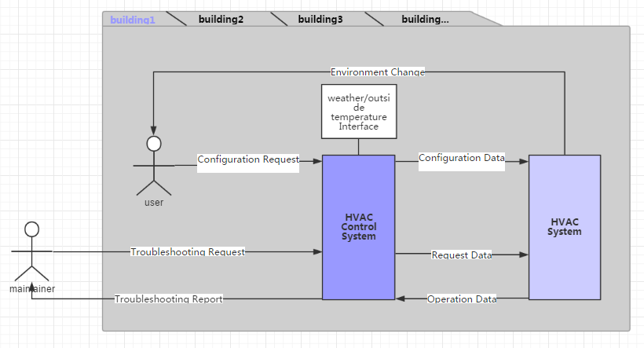

## Processes involved in fielding, commissioning, using, maintaining and retiring the system.

Fielding the system should be done according to each building characteristics to adapt to the stakeholders requirements, and that the systems components are well designed and installed. Validation and testing process should be set to assure that the system is operating as expected by the operational requirements of the stakeholders.

Maintenance plan should be set to react quickly (as possible) to any unwanted behavior of the system and the information collected should be in real time. Retiring the system depends on the technical and environmental limits of the system components.

# Project Plan

## Gantt Chart

The GANTT chart has been added as an attachment to this document. There are several GANTT charts that show each phase of the project, and one that shows the total overview of the project.

## PERT/CPM

Pert has been added as an attachment. It is basically the GANTT chart with little to no changes in timeline. All the tasks follow each other. Since the tasks follow each other the CPM is identical to the PERT diagram.

# Project Team

## Belbin test result

Self and team assessment using Belbin team roles

Leadership Dimensions Engaging The team Leading With care

Dr Meredith Belbin's work over 30 years has identified 9 clusters of behaviour, which he calls 'team roles'. Each team-role has a combination of strengths and allowable weaknesses. The value of Belbin® team role theory lies in enabling an individual or team to benefit from self knowledge, which provides the foundation for team building and allows you to adjust to meet demands arising from the change project. Belbin suggests that, by understanding your team role within a particular team, you can develop your strengths and manage your weaknesses as a team member, and so improve how you contribute to the team.

Team leaders and team development practitioners often use the Belbin model to help create more balanced teams.

• If team members have similar weakness, the team as a whole may tend to have that weakness.

• If team members have similar team-work strengths, they may tend to compete - rather than cooperate - for the team tasks and responsibilities that best suit their natural styles.

You can use the Belbin model with your team to help ensure that necessary team roles are covered, and that potential behavioral tensions or weaknesses among the team members are addressed.

Legend:

SH - Shaper

CO - Co-ordinator

PL - Plant

RI - Resource investigator

ME - Monitor evaluator

IMP - Implementer

TW - Team worker

CF - Completer finisher

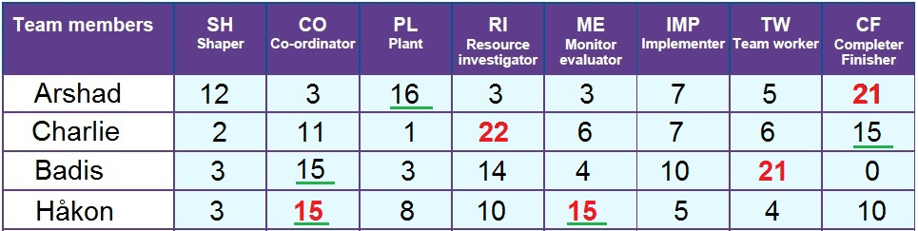

As shown in the above table, each team member has a different role according to the assessment, and that is by following the higher scores for each member.

## Organization Structure

We are a startup company of 4 members working on the smart facility management project, we are a flat organization so the team is horizontal which means that there are no levels of middle management and the team members are all directly involved in the decision making process.

The flat organization model promotes employee involvement through a decentralized decision-making process. By elevating the level of responsibility of baseline employees and eliminating layers of [middle management](https://en.wikipedia.org/wiki/Middle_management), comments and [feedback](https://en.wikipedia.org/wiki/Feedback) reach all personnel involved in decisions more quickly.

# Risk Management Plan

*Risk* is the possibility of loss or injury.*Project risk* is an uncertain event or condition that, if it occurs, has an effect on at least one project objective. *Risk management* focuses on identifying and assessing the risks to the project and managing those risks to minimize the impact on the project. There are no risk-free projects because there are an infinite number of events that can have a negative effect on the project. Risk management is not about eliminating risk but about identifying, assessing, and managing risk.

Here is an analysis of potential risks categorized in: overall project related risks, task risks and risks related to the business. And the source of each is identified then quantified by its level of probability of occurrence. And we thought of a strategy to mitigate it.

|  |  |  |  |  |
| --- | --- | --- | --- | --- |
| Type | Source | Level | Strategy | Solution |
| Project Risk | Lack of competence | Medium | Reduction | Do internal or external training to make sure the |
| Project delay | High | Prevention | Be sure that project leader follow up on the groups work. And the group has knowledge about the project delay. |
| Task Risk | Not compatible with current system | High | Prevention | Verify current systems and its standards |
| Business Risk | Solution is similar to something on the market | Medium | Prevention | Keeping track of current trends and systems on the market |